IP Camera

Smartphone -ready colour night/day

network camera with pan, tilt and zoom
DYN-C500

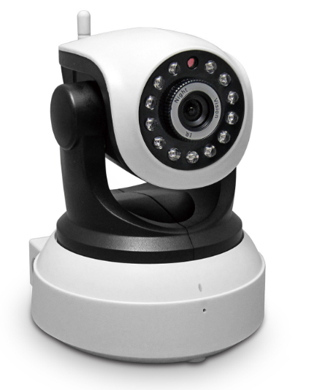

Introduction:
The 631GB series is the new H.264 Plug and Play indoor IP Camera. Once you connect camera to internet, no need any setting, you can see anywhere, any place, via manufacturer Mobile phone and PC and tablet software to view what you care for!

One key wifi setting. No need network cable, use your mobile help IP Camera connect with WIFI.
Support 64G SD card socket for recording storage;
Have Widows PC client and Mac pc client;
P2P, Plug and Play;
1.0 Mega pixels CMOS lens;
Support PIR detection;
Support two way intercom; Build-in Mic and loudspeaker;
631GB +Mobile/Tablet/PC +iSmartViewPro =3 steps Install;
Support 3 kinds of H.264 video stream and 1 way MJPEG video stream; Simultaneously, suitable for Local, Internet and Cross-platform view;
Support resolution for 1280*720/640*360/320*180; 720P HD;
Support 4 ways view in a video stream;
Support 802.11b/g/n protocol, build-in WiFi module to perform wireless monitoring;
Support rotate 350° horizontally and 90° vertically;
Built-in IR_CUT, 3.6 mm lens; 12pcs IR LED, up to 8meter night vision;
Built-in web server, use one port to send all the data, users can facilitates network setting;
Support ONVIF and RTSP protocol, easy to integrate it to NVR or large client software;
Support WPS/QSS function;
Support POE function, user optional;
Support multi-languages web interface, support multi-screen to perform several view at same time;
Manufacturer puts a label of DDNS at the bottom of each IP Camera. When IP Camera is connected to the internet, this URL can be used to visit the device;
Provide free client software, support Multi-view, Long time recording, video replay etc;
Motion Detection,
Audio detection and Audio alarm.

Specification
Model | 631GB
Hardware performance | Product type | IP camera
 | Operation system | Embedded operating system
 | Special function | One key WIFI setting; Support 64G SD/TF card; have Mac PC client.
Web environment | Web protocol | TCP/IP、UDP/IP、HTTP、SMTP、FTP、DHCP、DDNS、P2P、UPNP、NTP、RTSP、ONVIF
 | LAN port | 10Base-T/100Base-TX
 | Wifi | WIFI，802.11 b/g/n
Image performance | Resolution | 720P、640*360、320*180
 | Compression mode | H.264/M-JPEG
 | Max frame rate | 30fps
Other parameters | Lens | f=3.6mm, F=2.0
 | Min. illumination | IR on, 0 Lux
 | Electronic shutter | 1/50s(1/60s)-1/100,000 s
 | SNR | 48db
 | Safety performance | Three levels of user rights
 | Install mode | Wall-mounted / ceiling-mounted
 | Other performance | PC software,support for Microsoft Windows 98/2000/XP/Vista/Windows 7/Mac OS,And the Internet Explorer6.1 and above version or browser compatibility, Firefox, etc.,  provide iSmartViewPro client software
 | Power supply | DC 5V
 | Sensor | CMOS Sensor
 | IP camera performance | Support video control, Two-way voice talkback, motion detection, external alarm(sends information to alarm the server by Email, FTP);  Manufacturers provide free DDNS, and has been written into equipment;  12pcs IR LEDs,8 meters effectively;  Platform level angle 350 °,90 °vertical angle;  automatically control through the photoresistor;
 | Audio input | With microphone
 | Audio output | With speaker,  Provide the audio output interface
 | Alarm in | Not supported
 | Alarm out | Not supported
 | Power consumption | Power<6W
Appearance parameters | Body size | 105*116*126mm
 | Product weight | 0.40kg
Environment parameters | Environment temperature | -10℃~50℃
 | Environment humidity | below 85% RH

Packing List
1, IP Camera* 1
2, Driver and tool CD *1
3, Network Cable*1
4, 5V Power Adapter *1
5, Wi-Fi Antenna*1
6, Bracket * 1

